# Analysis of Fuzzy Logic Payment Mechanisms for Prosumer Energy Networks of Varying sizes

**Gathering Data for Prosumer and Consumer in an Energy Market**

The prosumers data was generated for 3,5,10 different prosumers. The data was generated parametrically and used in a database file. When querying the data, the parameters where chosen for each set of N prosumers. The average demand (consumption) and the average generation where chosen. The variance from the average curves where then chosen to be 10%.

db = 'data/prosumer_N100_all_20210409_00.csv'

query= {

    "N" : [3,5,10],

    "demand" : 800, *# kWh/mo*

    "generation" : 1300, *# kWh/mo*

    "demand_variance" : 0.1, *# %*

    "generation_variance" : 0.1 *# %*

}

Each prosumer’s consumption and generation has been synthesized then averaged together to show the overall movement of generation and consumption across the months. Notice that generation is much larger than consumption on average.

**Programming the Fuzzy Logic Controller for Payment of Prosumers**

The energy market exists of prosumers and consumers. The overall production and the overall consumption are inputs to the fuzzy logic controller that dictates the current pricing of energy and the current cost of energy. The controller is built so that the rules encourage generation when the demand (consumption) is high. It does this by increasing the cost to consume energy and also increasing the price paid to prosumers to generate energy. The fuzzy logic works best when the generation is fluctuating across the network as the demand also rises and falls based on its average load curve at any given time. These factors are generalized as threshold values to the fuzz logic membership functions.

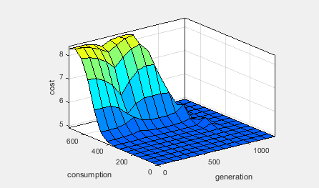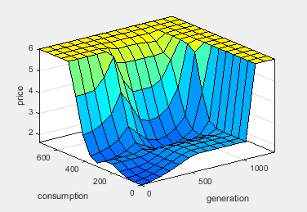

**Fuzzy Logic Implementation of N Prosumers**

Applying the dataset of consumption and generation to each time period (t=1 to 15) the output of the fuzzy logic controller provided the Price and Cost value.

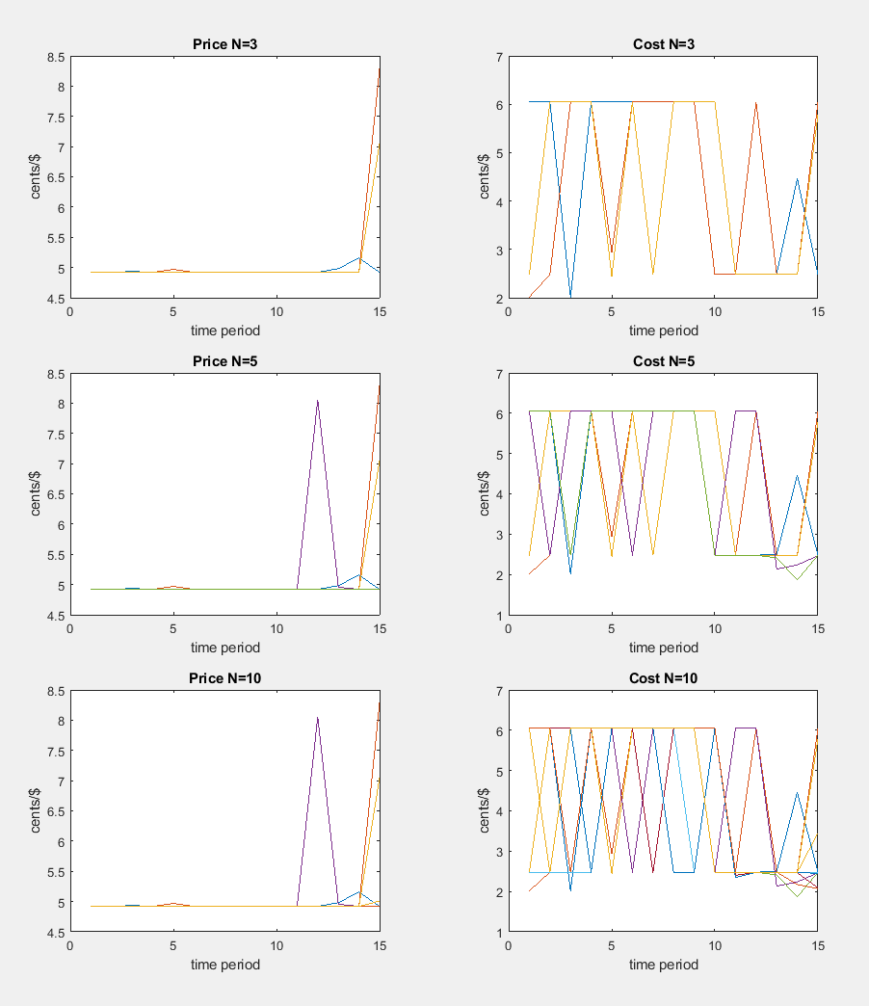

**Cumulative Plot of All Prosumers in Network**

By summing each prosumers generation and each consumer demand we can plot a cumulative chart across all the prosumers at each analysis of the network size ‘N’.

